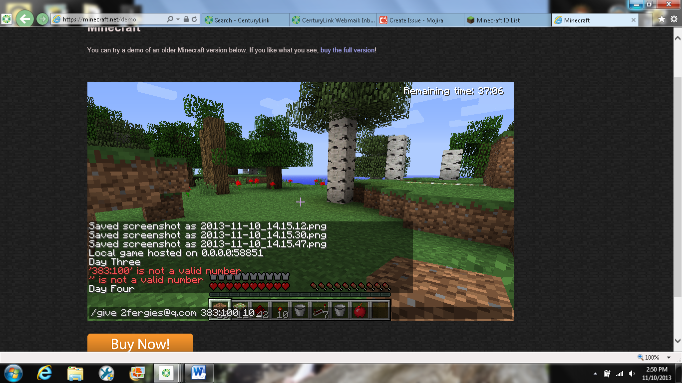

Before hitting enter.

This is what you should have in before hitting enter. The black box is to cover my screen name for safety reasons.

After hitting enter

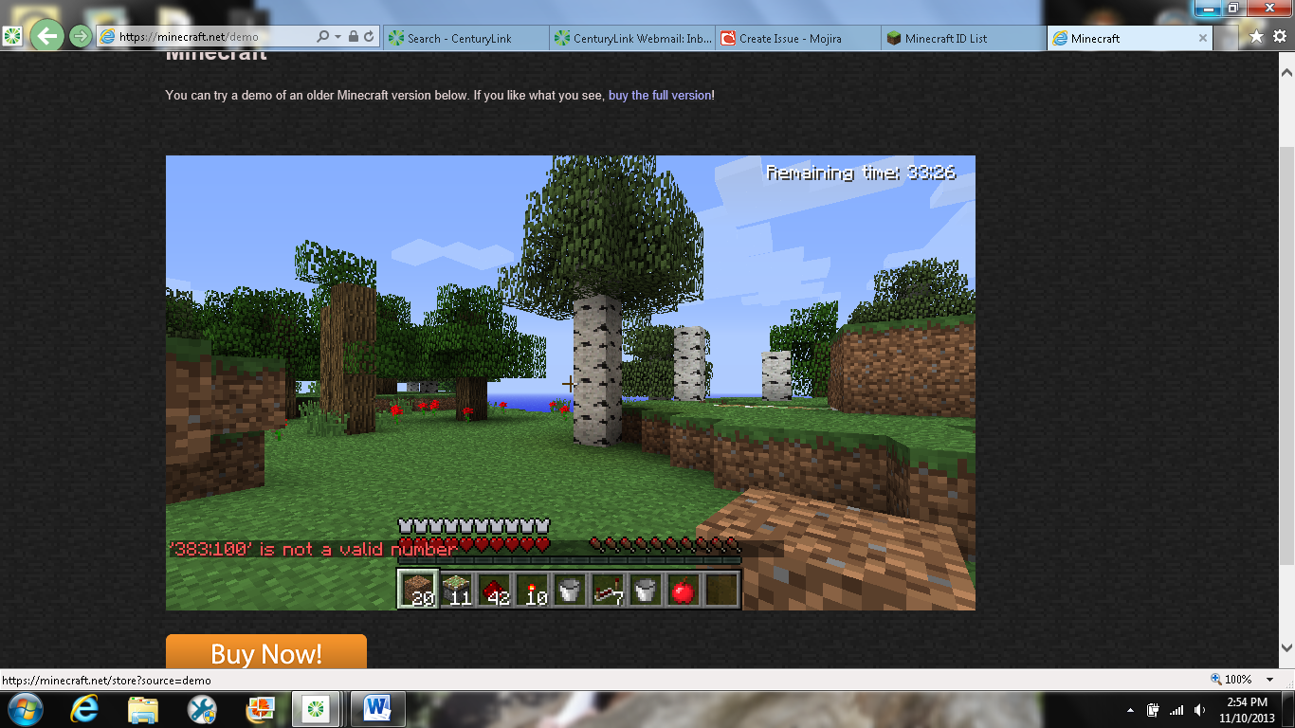

If you would like to check the item ID please go to this link. <http://minecraft-ids.grahamedgecombe.com/>

This is what you what you will get.