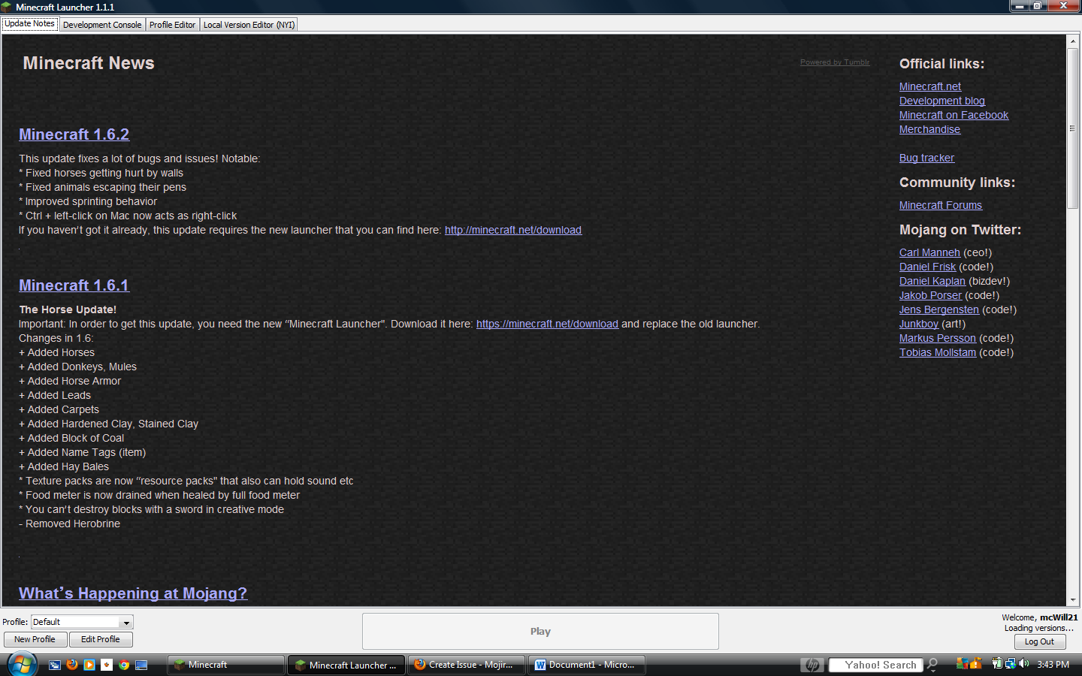

Launcher 1.1.1 (through bootstrap 5) started on windows...

Current time is Jul 19, 2013 3:28:45 PM

System.getProperty('os.name') == 'Windows Vista'

System.getProperty('os.version') == '6.0'

System.getProperty('os.arch') == 'x86'

System.getProperty('java.version') == '1.7.0_25'

System.getProperty('java.vendor') == 'Oracle Corporation'

System.getProperty('sun.arch.data.model') == '32'

Unexpected exception refreshing version list

java.lang.NullPointerException

at net.minecraft.launcher.updater.VersionList.addVersion(VersionList.java:90)

at net.minecraft.launcher.updater.LocalVersionList.refreshVersions(LocalVersionList.java:44)

at net.minecraft.launcher.updater.VersionManager.refreshVersions(VersionManager.java:47)

at net.minecraft.launcher.Launcher$2.run(Launcher.java:169)

at java.util.concurrent.Executors$RunnableAdapter.call(Unknown Source)

at java.util.concurrent.FutureTask$Sync.innerRun(Unknown Source)

at java.util.concurrent.FutureTask.run(Unknown Source)

at java.util.concurrent.ThreadPoolExecutor.runWorker(Unknown Source)

at java.util.concurrent.ThreadPoolExecutor$Worker.run(Unknown Source)

at java.lang.Thread.run(Unknown Source)

Loaded 4 profile(s); selected 'Default'

Refreshing auth...

Logging in with access token

Delta time to compare resources: 1737 ms

Download job 'Resources' skipped as there are no files to download

Job 'Resources' finished successfully